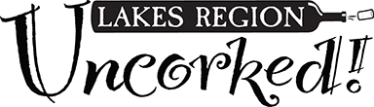

# _____ Tickets @ $100 each/Admits 2

# _____ Tickets @ $60 each/single

# _____ Premier tickets @ $95 each/single

__ 5:30 PM or __ 6:30 PM or __ Either Seating

# ___ ‘Blue Ribbon’ Raffle tickets @ $20 each/

6 for $100.

# ____ Total Tickets

**I want to support LRCS Foundation but am unable to attend. Enclosed is my donation of:**

$ _______

$ _______ Total Amount Enclosed

##### Name(s):

##### Affiliation: ___________

##### Mailing Address:

##### 

##### Email:

##### Phone:

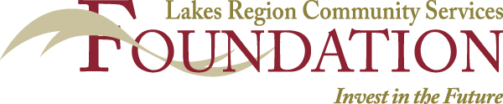

**GENERAL ADMISSION**

**$100/Admits 2**

**$60/Admits 1**

Includes full access to the event tasting rooms, silent auction and Wall of Wine raffles and an Uncorked LOGO glassware keepsake.

##### BLUE RIBBON

##### WALL OF WINE RAFFLE TICKETS

**$20 each / 6 tickets for $100.**

Only 250 tickets

will be sold. Winner does not need to be present.

*The custom wine rack and collection are valued at over $1,000.*

##### PREMIER TICKET

##### 

###### $95 per person

Includes General Admission Privileges

*Plus*

**Celebrity Chef Demonstration/ Tasting**

*​And*

##### 1 Blue Ribbon Raffle Ticket

($20 value) for a chance to win a

Custom wine collection/wine rack

**Premier Ticket’s sales are limited**

Choice of 2 Seatings:

5:30PM or 6:30 PM

##### TICKET INFORMATION

*.*

**By Mail:** Send checks payable to **LRCS Foundation** to:

LRCS Uncorked, PO Box 509, Laconia, NH 03247

**Online:** uncorkednh19.eventbrite.com *or*

lakesregionuncorked.com

**2019 TICKET ORDERS**

All ticket holders and participants must be 21 years or older for admittance.